
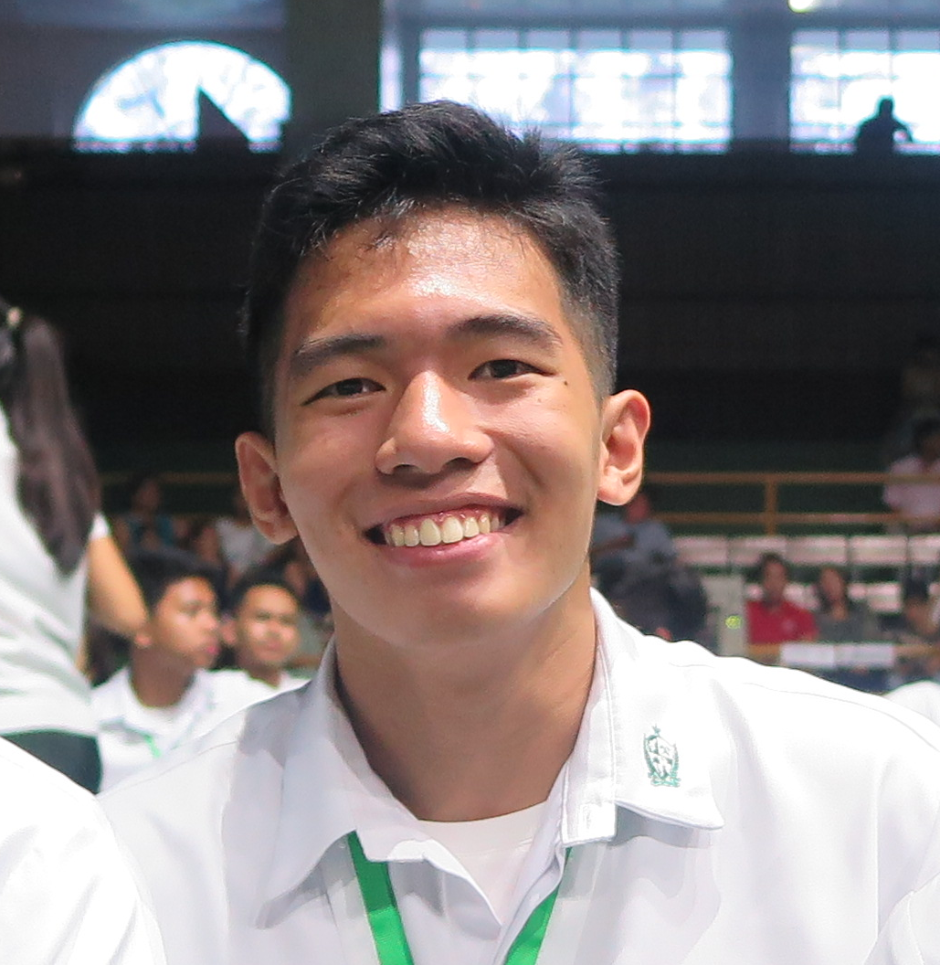
Simon Regs M. Regalado
292 Upper Paredes Street, Koronadal City, South Cotabato
+639054638333
pimonregalado@yahoo.com

OBJECTIVE
To join an organization where I can use my skills in personnel administration and attain a high level of performance in personnel recruitment and training.

EDUCATION

2018-Present de la salle university
Bachelor of Science degree in Mechanical Engineering Specialization in Mechatronics, December 2018.

2011-2018 DE LA SALLE LIPA
High School Diploma, June 2018. Awards: Achiever, 2018

CO-CURRICULAR ACTIVITIES

2017-2018 capstone Initiatives
Initiated the following projects: CAPSTONE Project

SEMINARS ATTENDED

March 2018 Capstone seminar
Student Development Office, De La Salle Lipa

PERSONAL BACKGROUND

Fluent in English and Filipino. Knowledgeable in Microsoft programs and Adobe Suite programs, and CAD programs. Interests: handicraft, photo-video editing, wood and metal working and CAD Design. Adaptable ,goal-oriented and quality oriented.

REFERENCES

Dr. joseph angelou ng
Science Professor
(NUMBER); (EMAIL)
(ADDRESS)

GRACE GUAVES
Thesis Adviser
(NUMBER); (EMAIL)
(ADDRESS)

